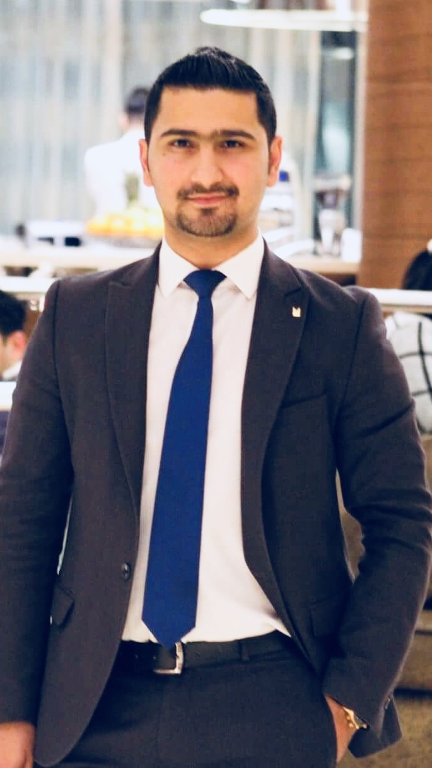

**Curriculum Vitae**

**Shahan Omer**

**Personal Information**

Address: Sulaimani, Iraq

Mobile No.: +9647723336056

Email: Shahan.Omer.Ghareeb@gmail.com

Date of Birth: May 14th, 1991

Nationality: Iraqi

## Career History

**Cluster Sales Manager July 1st 2018 – Present**

**Millennium & Copthorne Sulaimaniyah Hotels**

Three Hotels Grand Millennium (5 ★★★★★), Millennium Kurdistan Hotel & Spa (5 ★★★★★), Copthorne Hotel Baranan (4 ★★★★) and Ashur Resort. Located to the best places in Sulaimaniyah where the new business & leisure districts. Grand Millennium Sulaimani Hotel with 253 rooms & suites, Millennium Kurdistan Hotel & Spa with 135 rooms and suites and Copthorne Hotel Baranan with 78 rooms & suites combining a modern, contemporary style with the local touch of hospitality, guests will experience stylishly innovative designs and polished professional service.

**Main Responsibilities:**

A sales manager must be very clear about his role in the organization. He should know what he is supposed to do at the workplace.

Let us understand the roles and responsibilities of a sales manager:

* A sales manager is responsible for**meeting the sales targets** of the organization through effective planning and budgeting.
* A sales manager can’t work alone. He needs the support of his sales team where each one contributes in his best possible way and works towards the goals and objectives of the organization. He is the one who sets the targets for the sales executives and other sales representatives. A sales manager must ensure the targets are realistic and achievable.
* The duties must not be imposed on anyone, instead should be delegated as per interests and specializations of the individuals. A sales manager must understand who can perform a particular task in the most effective way. It is his role to extract the best out of each employee.
* **A sales manager devises strategies** and techniques necessary for achieving the sales targets. He is the one who decides the future course of action for his team members.
* It is the sales manager’s duty to **map potential customers and generate leads for the organization**. He should look forward to generating new opportunities for the organization.
* A sales manager is also responsible for **brand promotion**. He must make the product popular amongst the consumers. A banner at a wrong place is of no use. Canopies must be placed at strategic locations; hoardings should be installed at important places for the best results.
* **Motivating team members** is one of the most important duties of a sales manager. He needs to make his team work as a single unit working towards a common objective. He must ensure team members don’t fight amongst themselves and share cordial relationship with each other. Develop lucrative incentive schemes and introduce monetary benefits to encourage them to deliver their level best. Appreciate whenever they do good work.
* It is the sales manager’s duty to ensure his **team is delivering desired results**. Supervision is essential. Track their performances. Make sure each one is living up to the expectations of the organization. Ask them to submit a report of what all they have done throughout the week or month. The performers must be encouraged while the non-performers must be dealt with utmost patience and care.
* He is the one who takes major decisions for his team. He should act as a pillar of support for them and stand by their side at the hours of crisis.
* A sales manager should set an example for his team members. He should be a source of inspiration for his team members.
* A sales manager is responsible for not only selling but also **maintaining and improving relationships with the client**. Client relationship management is also his KRA.
* As a sales manager, one should maintain necessary data and records for future reference.

**Asst. Sales Manager January 1st 2017 – Present**

**Millennium & Copthorne Sulaimaniyah Hotels**

Three Hotels Grand Millennium (5 ★★★★★), Millennium Kurdistan Hotel & Spa (5 ★★★★★) and Copthorne Hotel Baranan (4 ★★★★) located to the best places in Sulaimaniyah where the new business & leisure districts. Grand Millennium Sulaimani Hotel with 253 rooms & suites, Millennium Kurdistan Hotel & Spa with 135 rooms and suites and Copthorne Hotel Baranan with 78 rooms & suites combining a modern, contemporary style with the local touch of hospitality, guests will experience stylishly innovative designs and polished professional service.

**Main Responsibilities:**

Sells products by implementing sales plans; supervising sales staff:

* Checking customer satisfaction and resolving any issues to ensure repeat business
* Determines annual unit and gross-profit plans by implementing marketing strategies; analysing trends and results.
* Establishes sales objectives by forecasting and developing annual sales quotas for regions and territories; projecting expected sales volume and profit for existing and new products.
* Conduct market research to identify selling possibilities and evaluate customer needs
* Actively seek out new sales opportunities through cold calling, networking and social media
* Set up meetings with potential clients and listen to their wishes and concerns
* Prepare and deliver appropriate presentations on products/ services
* Create frequent reviews and reports with sales and financial data
* Ensure the availability of stock for sales and demonstrations
* Participate on behalf of the company in exhibitions or conferences
* Negotiate/close deals and handle complaints or objections
* Collaborate with team to achieve better results
* Identifying new contacts and developing sales leads
* Ensuring enquiries become confirmed business
* Upselling where possible
* Producing written quotations and confirmation
* Implements national sales programs by developing field sales action plans.
* Maintains sales volume, product mix, and selling price by keeping current with supply and demand, changing trends, economic indicators, and competitors.
* Establishes and adjusts selling prices by monitoring costs, competition, and supply and demand.

**Front Desk Manager May 1st 2016 – January 1st 2017**

**Millennium & Copthorne Sulaimaniyah Hotels**

A five star hotel located the Best place in Sulaimaniyah the new business & leisure districts. With 253 rooms & suites combining a modern, contemporary style with the local touch of hospitality, guests will experience stylishly innovative designs and polished professional service.

**Main Responsibilities:**

* Assigned duties and shifts to workers
* Coached and counselled employees to ensure adherences to hotel policies, standards and procedures.
* Recruited, managed, trained and developed the front office/desk team.
* Analyzed, investigated and resolved guest complaints
* Coordinates monthly staff meetings that address any outstanding issues and record the minutes as well as record the agenda.
* Reconcile the daily cash log and night audit report
* All other duties as assigned by the General Manager

**Duty Manager October 1st 2015 – May 1st 2016**

**Millennium & Copthorne Sulaimaniyah Hotels**

A five star hotel located the Best place in Sulaimaniyah the new business & leisure districts. With 253 rooms & suites combining a modern, contemporary style with the local touch of hospitality, guests will experience stylishly innovative designs and polished professional service.

**Main Responsibilities:**

* Manage and maintain all year or seasonal lodging facilities.
* Observe and monitor workers' performance to make sure that company rules and procedures are being followed.
* Confer and cooperate with other department managers to coordinate hotel activities, such as weddings.
* Answer questions about hotel policies and services. They also resolve customer’s complaints.
* Arrange telephone answering service, mail delivery, and answers customers questions about area.
* Use computers to order food and beverages, or prepare reports.
* Purchase supplies or services from outside vendors, such as laundry, repair, and trash.
* Inspect hotel for cleanliness and appearance.
* Coordinate front-office duties and resolve problems.
* Greet and register guests.
* Show, rent, or assign rooms or cabins.
* Collect payment and record money earned and spent.
* Receive and process advance payments. They usually send out letters to confirm that they have received payment. They may return checks if space is not available.
* Interview and hire staff.

**Guest Relation Executive June 1st 2015 – October 1st 2015**

**Millennium & Copthorne Sulaimaniyah Hotels**

A five star hotel located the Best place in Sulaimaniyah the new business & leisure districts. With 253 rooms & suites combining a modern, contemporary style with the local touch of hospitality, guests will experience stylishly innovative designs and polished professional service.

**Main Responsibilities:**

Attend to guests courteously and deal promptly with their requests and queries. Have detailed information about the hotel and city. Check on VIP guest movements, complete their pre-registration formalities.

allocate rooms to all arriving guests after checking the guest preferences. Collect guest feedback forms and do any possible first hand service recovery steps.

* Welcome guests during check-in and giving a fond farewell to guest while checkout.
* Handling guest complaints and concerns in an efficient and timely manner.
* Overseeing VIP guests, arrivals and departures.
* Coordinating and multi-tasking job duties in a busy environment like handling check-in and check-outs along with cashiering as well as handling shift alone.
* Should possess detailed information about the Hotel, city as well as the competition.
* Detailed information regarding arrivals and room requirements.
* Have up to date information on daily room occupancy
* Providing excellent customer service as per hotel standards.
* Allocate rooms to all arriving guests.
* Maintain up-to date information on room rates, current promotions, offers and packages
* Maintain all guest folios in the manner instructed and type out necessary guest likes and dislikes to the appropriate fields on the profile.
* Co-ordinate with housekeeping for clearing of rooms.
* Collect Guest feedback during guest departure along with his likes and dislikes.
* Perform basic cashier activities as and when required.
* Ensure that all check-ins and check-outs are handled smoothly without unnecessary delay or discomfort to any guest.
* Should be able to handle all guests without bias or prejudice.

**Telephone Operator January 1st 2014 – June 1st 2015**

**Millennium & Copthorne Sulaimaniyah Hotels**

A five star hotel located the Best place in Sulaimaniyah the new business & leisure districts. With 253 rooms & suites combining a modern, contemporary style with the local touch of hospitality, guests will experience stylishly innovative designs and polished professional service.

**Main Responsibilities:**

Speaks clearly, distinctly, and with a friendly, courteous tone. Uses listening skills to put callers at ease and obtains accurate, complete information. Answers incoming calls and directs them to guest rooms through the telephone console or to hotel personnel or departments.

Takes and distributes messages for guests, provides information on guest services, and answers inquiries about public hotel events.

* Answers incoming calls and Places outgoing calls.
* Directs call to guest rooms, staff, or departments through the switchboard or PBX system.
* Receives guest messages and deliver the same to the guest.
* Logs all wake-up call requests and performs wake-up call services.
* Provides information about hotel services to guests.
* Knows what action to take when an emergency call is required.
* Assists in reporting telephone equipment or service complaints and problems.
* Following telephone etiquette
* Trains or assists with training new telephone operators in performance of job duties.
* To be fully aware of and adhere of health and safety, fire and bomb threat procedures.
* Must be polite and courteous while answering the phone.
* Update directory information on the front office software.

**Legal Translator February 1st 2013 – December 20th 2013**

**Organization of human rights studies (belong to United Nations)**

Under general direction, performs literal and general interpretation and translation from English to a specified foreign language and vice versa in a support capacity to attorneys, investigators, and other legal staff; performs miscellaneous clerical work; and performs related duties as required.

**Main Responsibilities:**

* Convert concepts in the source language to equivalent concepts in the target language
* Compile information, such as technical terms used in legal settings, into glossaries and terminology databases to be used in translations
* Speak, read, and write fluently in at least two languages, including English and one or more others
* Relay the style and tone of the original language
* Manage work schedules to meet deadlines
* Render spoken messages accurately, quickly, and clearly

## Education & Occupational Training Courses

June 2014: Bachelor English Languages and Literature, University of Sulaimaniyah

**Skills:**

* Public Relation
* Business Communication Skills ( Writing & Verbal)
* Writing Formal Emails
* Customer Services
* Well-Organized
* Negotiation
* Quick learning
* Reliability
* Creativity
* Multi-tasking
* Decision making, critical thinking, organizing and planning.
* Self-motivated, initiative, high level of energy.

**Computer Skills:**

* Excellent with Microsoft Office( Word , Excel, PowerPoint, Outlook)
* Opera Hotel System (Property Management system – Sales and Catering)
* Oasis System (Payroll)
* SCM System ( supply chain management system)

**Language Skills:**

* Kurdish (Native)
* English Excellent speaking and writing
* Arabic Excellent speaking and writing

**Profile:**

I am able to respond to the challenges of working in the hospitality industry, as I am very aware of many different cultures & to adapt all sorts of people. Having been working for almost 5 years and half in the hospitality industry and customer service has helped me to be more efficient & effective in my job.

I am a positive and hardworking individual, who always strives to achieve the highest standard possible, at any given task. I can make a strong combination to the company if given an opportunity to use the experience & knowledge that I have gained from my past experience, I possess excellent communication skills and I have the ability and experience to relate to a wide range of people. Always eager to learn more & search for new challenges all the time, I can work very well under pressure and I have the sales experience to handle customer complaints and solving problematic situations as well as on marketing, besides I have a very good background on administrative works.

**Reference furnished upon request**